**BANK LOAN QUERY DOCUMENT**

# BANK LOAN REPORT – SUMMARY

# KPI’S :

## Total Loan Applications

select COUNT(id) as Total_Loan_Applications from bank_loan_data



## MTD LOAN APPLICATIONS

select COUNT(id) as MTD_Total_Loan_Applications from bank_loan_data

where MONTH(issue_date) = 12 and YEAR(issue_date) = 2021



## PMTD LOAN APPLICATIONS

select COUNT(id) as PMTD_Total_Loan_Applications from bank_loan_data

where MONTH(issue_date) = 11 and YEAR(issue_date) = 2021



## TOTAL FUNDED AMOUNT

select SUM(loan_amount) as Total_Funded_Amount from bank_loan_data



## MTD TOTAL FUNDED AMOUNT

select SUM(loan_amount) as MTD_Total_Funded_Amount from bank_loan_data

where MONTH(issue_date) = 12 and YEAR(issue_date) = 2021



## PMTD TOTAL FUNDED AMOUNT

select SUM(loan_amount) as PMTD_Total_Funded_Amount from bank_loan_data

where MONTH(issue_date) = 11 and YEAR(issue_date) = 2021



## TOTAL AMOUNT RECEIVED

select SUM(total_payment) as Total_Amount_Received from bank_loan_data



## MTD TOTAL AMOUNT RECEIVED

select SUM(total_payment) as MTD_Total_Amount_Received from bank_loan_data

where MONTH(issue_date) = 12 and YEAR(issue_date) = 2021



## PMTD TOTAL AMOUNT RECEIVED

select SUM(total_payment) as PMTD_Total_Amount_Received from bank_loan_data

where MONTH(issue_date) = 11 and YEAR(issue_date) = 2021



## AVERAGE INTEREST RATE

select Round(AVG(int_rate),4) * 100 as Avg_Int_Rate from bank_loan_data



## MTD AVERAGE INTEREST

select Round(AVG(int_rate),4) * 100 as MTD_Avg_Int_Rate from bank_loan_data

where MONTH(issue_date) = 12 and YEAR(issue_date) = 2021



## PMTD AVERAGE INTEREST

select Round(AVG(int_rate),4) * 100 as PMTD_Avg_Int_Rate from bank_loan_data

where MONTH(issue_date) = 11 and YEAR(issue_date) = 2021



## AVG DTI

select Round(AVG(dti),4) * 100 as AVG_DTI from bank_loan_data



## MTD AVG DTI

select Round(AVG(dti),4) * 100 as MTD_AVG_DTI from bank_loan_data

where MONTH(issue_date) = 12 and YEAR(issue_date) = 2021



## PMTD AVG DTI

select Round(AVG(dti),4) * 100 as PMTD_AVG_DTI from bank_loan_data

where MONTH(issue_date) = 11 and YEAR(issue_date) = 2021



# **GOOD LOAN ISSUED**

## GOOD LOAN PERCENTAGE

SELECT

(COUNT(CASE WHEN loan_status = 'Fully Paid' OR loan_status = 'Current' THEN id END) * 100)

/

COUNT(id) AS Good_Loan_Percentage

FROM bank_loan_data



## GOOD LOAN APPLICATIONS

select COUNT(id) as Good_Loan_Applications from bank_loan_data

where loan_status = 'Fully Paid' or loan_status = 'Current'



## GOOD LOAN FUNDED AMOUNT

select sum(loan_amount) as Good_Loan_Funded_Amount from bank_loan_data

where loan_status = 'Fully Paid' or loan_status = 'Current'



## GOOD LOAN AMOUNT RECEIVED

select sum(total_payment) as Good_Loan_Received_Amount from bank_loan_data

where loan_status = 'Fully Paid' or loan_status = 'Current'



# **BAD LOAN ISSUED**

## BAD LOAN PERCENTAGE

select

COUNT(case when loan_status = 'Charged Off' then id end) * 100

/

count(id) as Bad_Loan_Percentage

from bank_loan_data



## BAD LOAN APPLICATIONS

select count(id) as Bad_Loan_Applications from bank_loan_data

where loan_status = 'Charged Off'



## BAD LOAN FUNDED AMOUNT

select sum(loan_amount) as Bad_Loan_Funded_Amount from bank_loan_data

where loan_status = 'Charged Off'



## BAD LOAN AMOUNT RECEIVED

select sum(total_payment) as Bad_Loan_Amount_Received from bank_loan_data

where loan_status = 'Charged Off'



# **LOAN STATUS**

select

loan_status,

COUNT(id) as Total_Loan_Applications,

SUM(total_payment) as Total_Amount_Received,

SUM(loan_amount) as Total_Funded_Amount,

AVG(int_rate * 100) as Interest_Rate,

AVG(dti * 100) as DTI

from

bank_loan_data

group by

loan_status

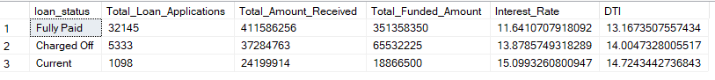

select

loan_status,

sum(total_payment) as MTD_Total_Amount_Received,

sum(loan_amount) as MTD_Total_Funded_Amount

from bank_loan_data

where MONTH(issue_date) = 12

group by loan_status

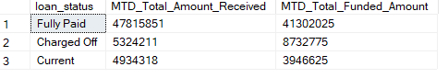

# **BANK LOAN REPORT – OVERVIEW**

## MONTH

select

MONTH(issue_date) as Month_Number,

DATENAME(month,issue_date) as Month_Name,

COUNT(id) as Total_Loan_Applications,

SUM(loan_amount) as Total_Funded_Amount,

SUM(total_payment) as Total_Amount_Received

from bank_loan_data

group by MONTH(issue_date) , DATENAME(month,issue_date)

order by month(issue_date)

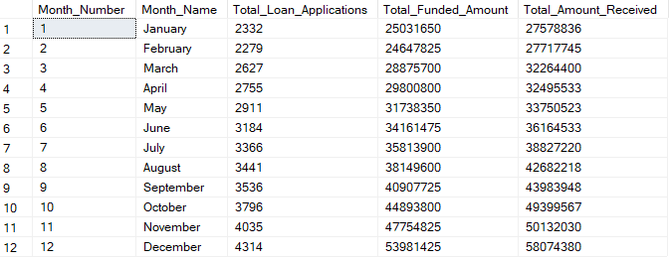

# STATE

select

address_state as State,

COUNT(id) as Total_Loan_Applications,

SUM(loan_amount) as Total_Funded_Amount,

SUM(total_payment) as Total_Amount_Received

from bank_loan_data

group by address_state

order by address_state

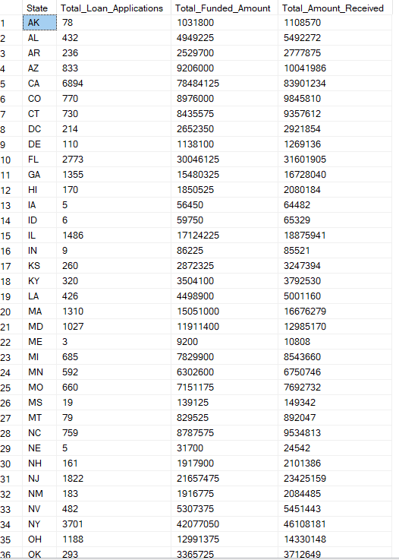

# **TERM**

select

term,

COUNT(id) as Total_Loan_Applications,

SUM(loan_amount) as Total_Funded_Amount,

SUM(total_payment) as Total_Amount_Received

from bank_loan_data

group by term

order by term

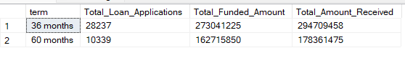

# **EMPLOYEE LENGTH**

select

emp_length,

COUNT(id) as Total_Loan_Applications,

SUM(loan_amount) as Total_Funded_Amount,

SUM(total_payment) as Total_Amount_Received

from bank_loan_data

group by emp_length

order by emp_length

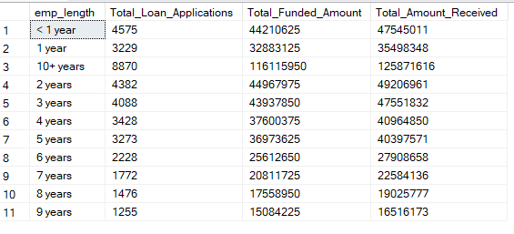

# **PURPOSE**

select

purpose,

COUNT(id) as Total_Loan_Applications,

SUM(loan_amount) as Total_Funded_Amount,

SUM(total_payment) as Total_Amount_Received

from bank_loan_data

group by purpose

order by COUNT(id) desc

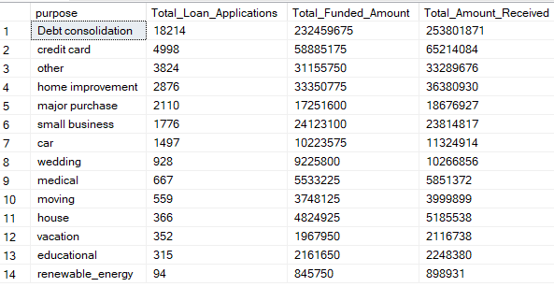

# **HOME OWNERSHIP**

select

home_ownership,

COUNT(id) as Total_Loan_Applications,

SUM(loan_amount) as Total_Funded_Amount,

SUM(total_payment) as Total_Amount_Received

from bank_loan_data

group by home_ownership

order by COUNT(id) desc

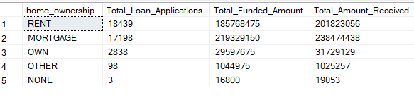

## GRADE A AND ADDRESS NY

select

home_ownership,

COUNT(id) as Total_Loan_Applications,

SUM(loan_amount) as Total_Funded_Amount,

SUM(total_payment) as Total_Amount_Received

from bank_loan_data

where grade = 'A' and address_state = 'NY'

group by home_ownership

order by COUNT(id) desc

